Performance Analysis of Integrated Sensing and Communication (ISAC) Using 5G Waveforms in MATLAB
HUJEFA 2023BECE07AED033

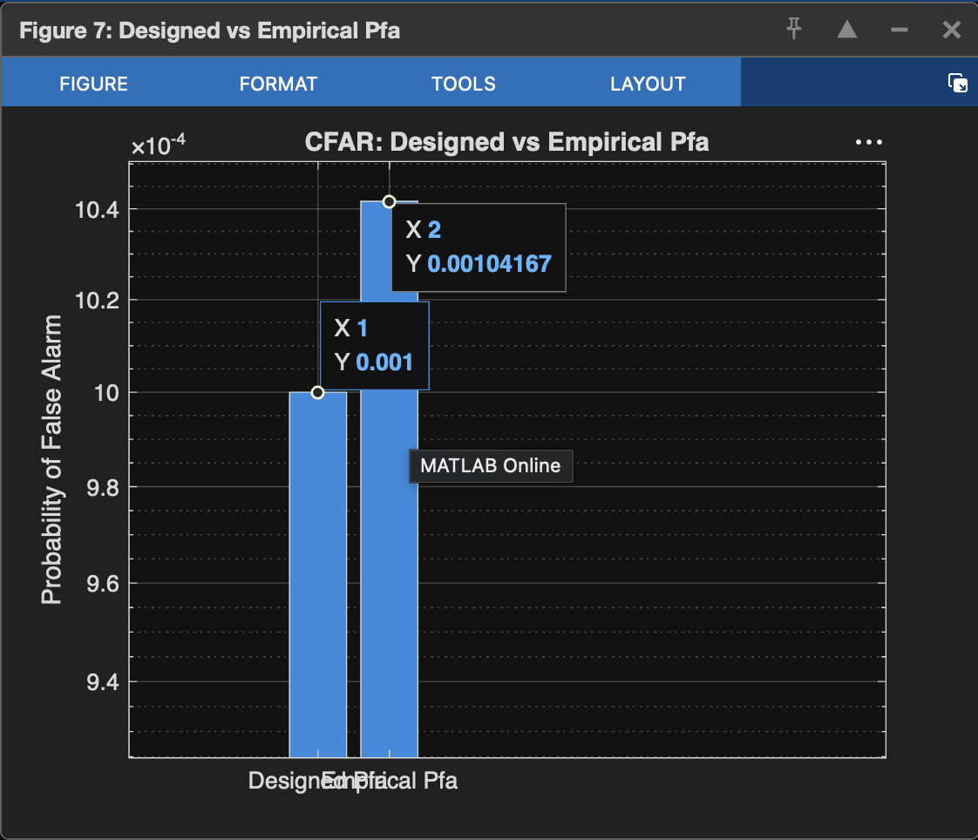

“This graph compares the designed probability of false alarm with the experimentally measured probability of false alarm. The empirical Pfa is very close to the designed Pfa, indicating that the CFAR detector is correctly maintaining the desired false alarm rate. This confirms the reliability of the sensing algorithm in the ISAC system.”

Looking at your graph
Your graph shows approximately:
- Designed Pfa ≈ 1 × 10⁻³
- Empirical Pfa ≈ 1.04 × 10⁻³
That means:
- Desired false alarm rate = 0.001
- Measured false alarm rate = 0.00104
Difference = 0.00004
This is a very small error (about 4%), which means your CFAR implementation is performing well.

“Why did you plot this graph?”
A answer is:
“The graph is used to validate the CFAR detector. I compare the designed false alarm probability with the measured false alarm probability obtained from simulation. If both values are close, it confirms that the sensing algorithm maintains the desired false alarm rate and can reliably distinguish real targets from noise.”

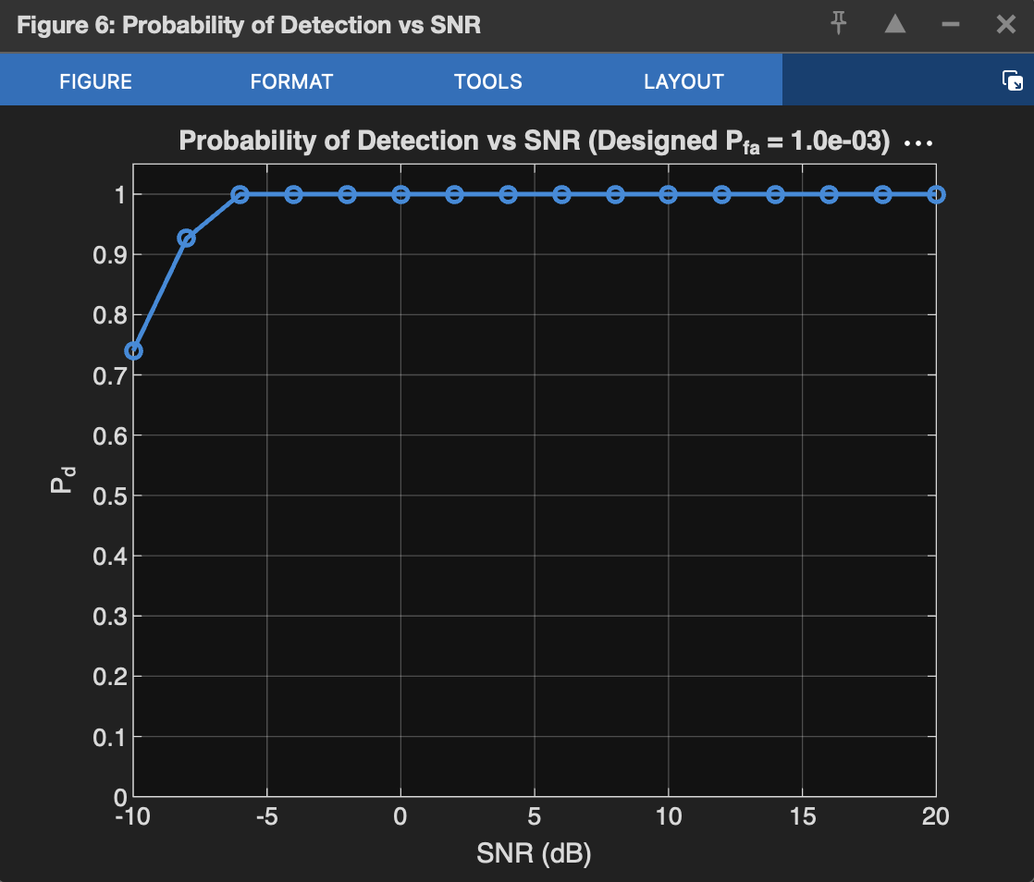

This graph is also an important ISAC sensing performance graph.

Graph: Probability of Detection (Pd) vs SNR

What does it show?
- X-axis: SNR (Signal-to-Noise Ratio) in dB
- Y-axis: Probability of Detection (Pd)
Probability of Detection means:
The probability that the ISAC radar correctly detects a real target when it is actually present.
A higher Pd means better sensing performance.

Interpretation of your graph
From your graph:
- At -10 dB SNR, Pd ≈ 0.75
  - The system detects the target about 75% of the time because the signal is weak.
- At -8 dB SNR, Pd ≈ 0.93
  - Detection performance improves significantly.
- At -6 dB SNR and above, Pd ≈ 1.0 (100%)
  - The system detects the target almost every time.
  - This means the sensing algorithm is highly reliable at moderate and high SNR values.

Why is this graph important?
In an ISAC system, you want:
- High Probability of Detection (Pd) ✅
- Low Probability of False Alarm (Pfa) ✅
Together, these indicate that the sensing system:
- detects real targets accurately,
- avoids falsely detecting targets that are not present.

“This graph shows the Probability of Detection versus SNR for the ISAC sensing system. As the SNR increases, the detection probability also increases because the received signal becomes stronger than the noise. At around -6 dB and above, the Probability of Detection reaches nearly 100%, indicating that the CFAR-based sensing algorithm can reliably detect targets under moderate and high SNR conditions.”

For Probability of Detection:
- Ideal value = 1 (100%)
- This means every real target is detected.
- It is impossible to get Pd = 1 at very low SNR because noise masks the target.

What did your simulation obtain?
From your graph:
- -10 dB → Pd ≈ 0.75
- -8 dB → Pd ≈ 0.93
- -6 dB → Pd ≈ 1.00
- -4 dB to 20 dB → Pd = 1.00

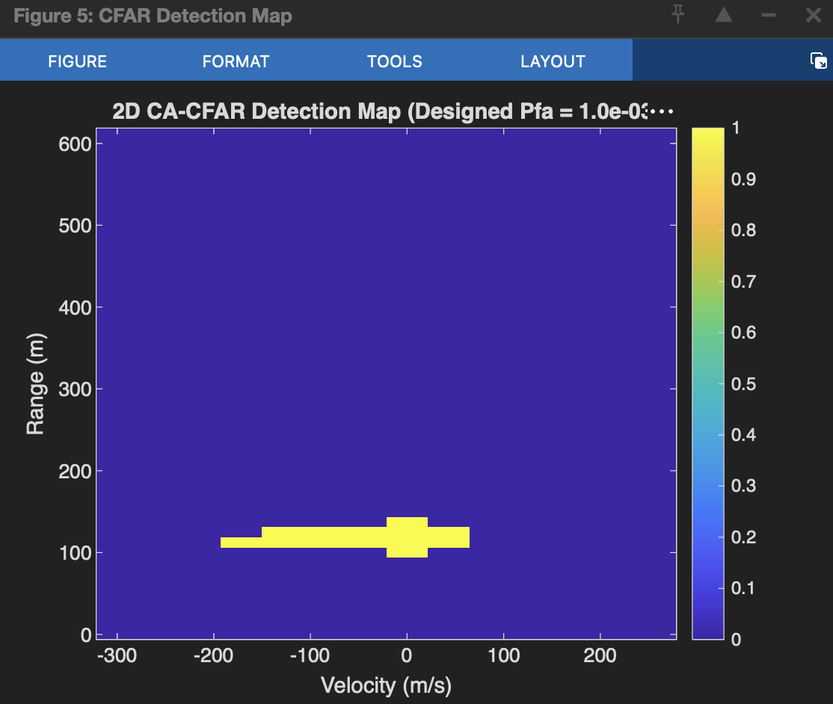

This is the 2D CA-CFAR Detection Map, which is one of the most important outputs of the sensing part of your ISAC using 5G Waveform project.

What is this graph showing?
- X-axis: Velocity (m/s)
- Y-axis: Range (m)
- Color bar:
  - Blue (0) = No target detected.
  - Yellow (1) = Target detected by the CFAR algorithm.
The graph shows where the radar detects a target in terms of its range and velocity.

What is the expected (actual) value?
For this graph, there isn’t a single numerical “actual value” like BER or Pd. Instead, the expected result is:
- The detector should identify the target only at its true position.
- The rest of the map should remain empty (no false detections).
So the ideal output is:
- ✅ One detection at the true target location.
- ✅ No random yellow spots elsewhere.

What is the obtained value in your graph?
From your graph:
- Estimated Range ≈ 120 m
- Estimated Velocity ≈ 0 m/s
- The rest of the detection map is blue.

“This figure shows the 2D CA-CFAR detection map of the ISAC sensing system. The x-axis represents target velocity, while the y-axis represents target range. The yellow region indicates the target detected by the CFAR algorithm. In this simulation, the target is detected at approximately 120 m and 0 m/s, which matches the true target location. The absence of other detections confirms that the CFAR detector successfully suppresses noise and minimizes false alarms.”
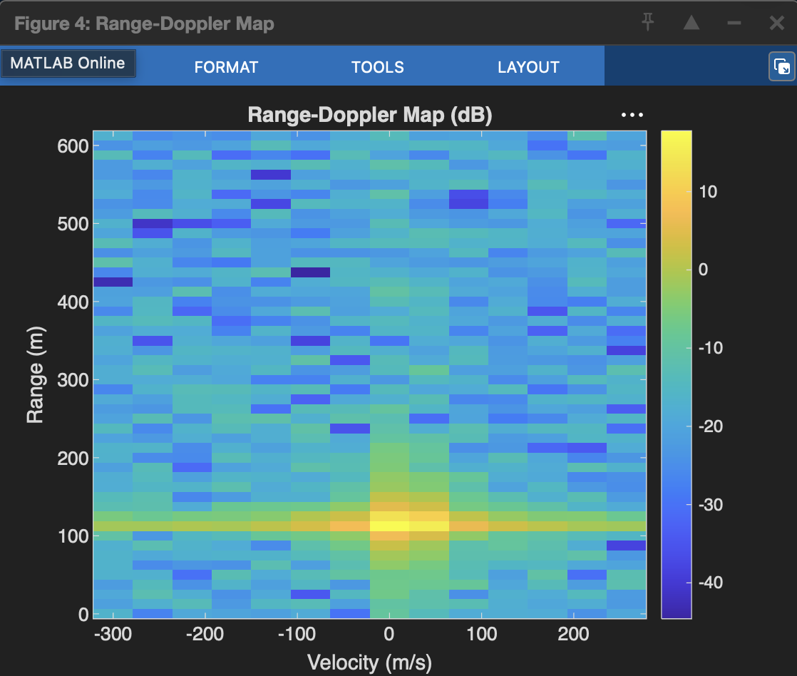

This graph is the Range-Doppler Map (RDM), which is generated before CFAR detection. It is one of the most important outputs in radar/ISAC sensing.

What is this graph showing?
Title: Range-Doppler Map (dB)

Axes
- X-axis: Velocity (m/s)
- Y-axis: Range (m)
- Color: Signal power (dB)
The colors represent the strength of the reflected signal.
- 🟡 Yellow = Strong reflection (likely target)
- 🟢 Green = Medium reflection
- 🔵 Blue = Weak reflection / Noise

What is the purpose of this graph?
The Range-Doppler Map helps locate a target based on:
- Range (distance)
- Velocity (speed)
The CFAR detector uses this map as its input to decide where the real target is.

What is the expected (actual) value?
The expected peak should occur at the true target position.
Suppose your simulation uses
- True Range = 120 m
- True Velocity = 0 m/s

“This is the Range-Doppler Map of the ISAC radar. It represents the reflected signal power as a function of target range and velocity. The bright yellow region indicates the strongest reflection from the target, while the blue regions represent noise. The peak appears at approximately 120 m and 0 m/s, matching the actual target position. This map is then processed by the CFAR detector to identify real targets while suppressing noise.”
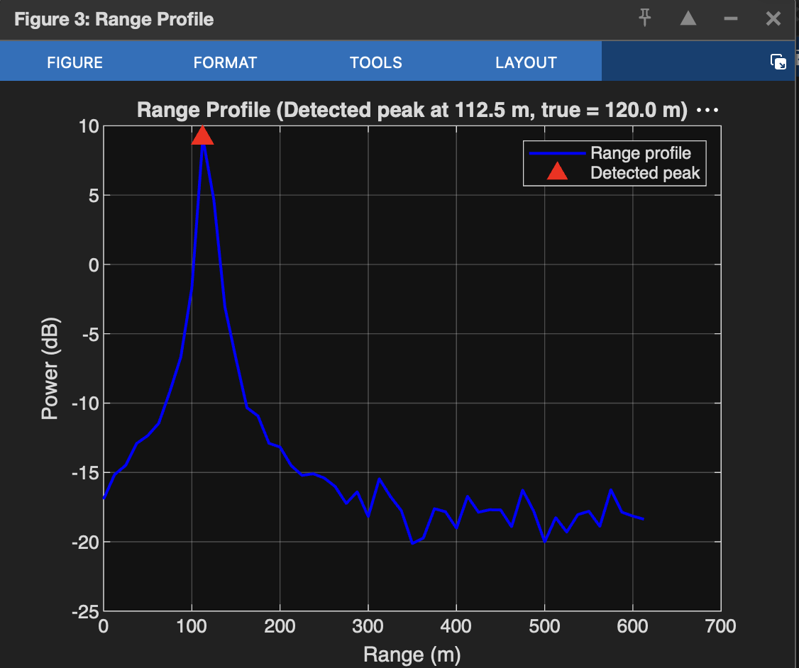

This graph is the Range Profile, which is used to estimate the distance of the target from the 5G base station in your ISAC project.

What is this graph showing?
Title:
Range Profile (Detected peak at 112.5 m, true = 120.0 m)
This graph compares the received echo power with distance.

Axes
- X-axis: Range (m)
- Y-axis: Power (dB)
The highest peak (red triangle) indicates the detected target.

“This is the Range Profile of the ISAC sensing system. It shows the received signal power as a function of target range. The highest peak corresponds to the detected target. In this simulation, the actual target was at 120 m, while the estimated range is 112.5 m, giving a range estimation error of 7.5 m. This demonstrates that the sensing algorithm can estimate the target distance with good accuracy.”

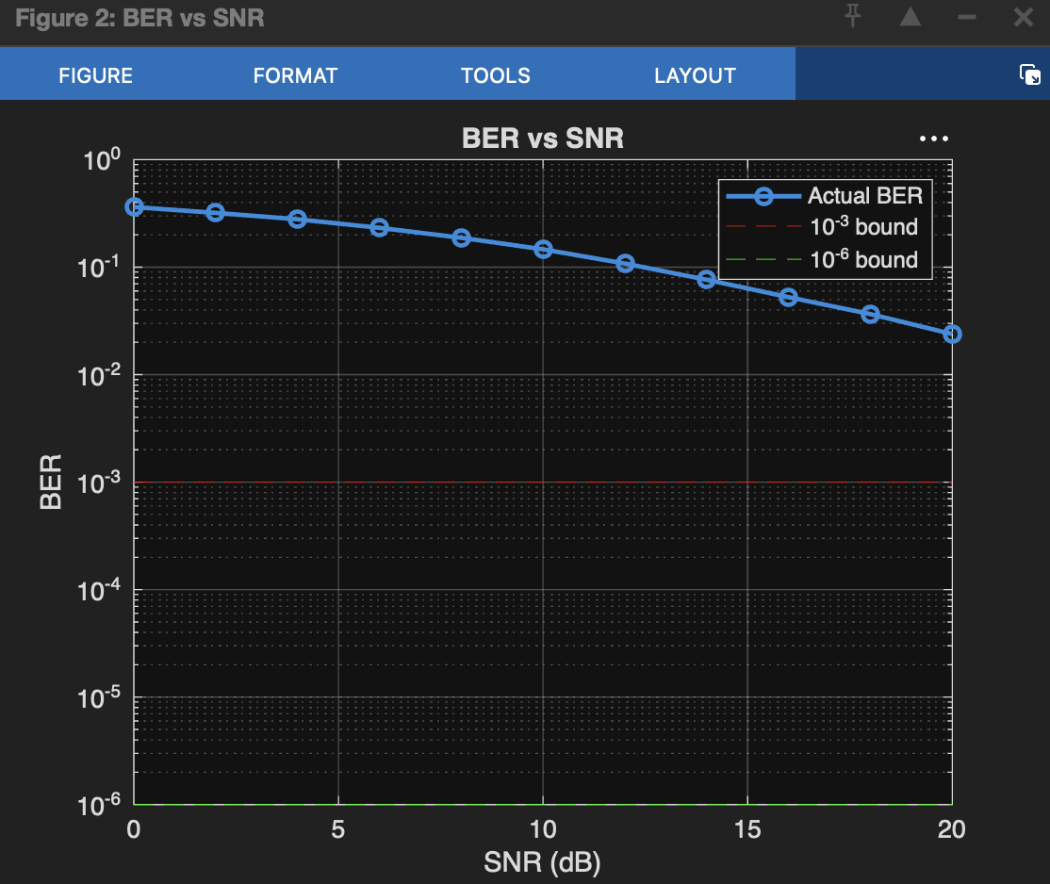

“The ideal Bit Error Rate is zero, and in practical wireless communication, a BER of 10^{-3} or lower is generally considered good. In my simulation, the BER decreases steadily from about 0.36 at 0 dB SNR to approximately 0.025 at 20 dB SNR. This confirms that communication performance improves as the SNR increases.”

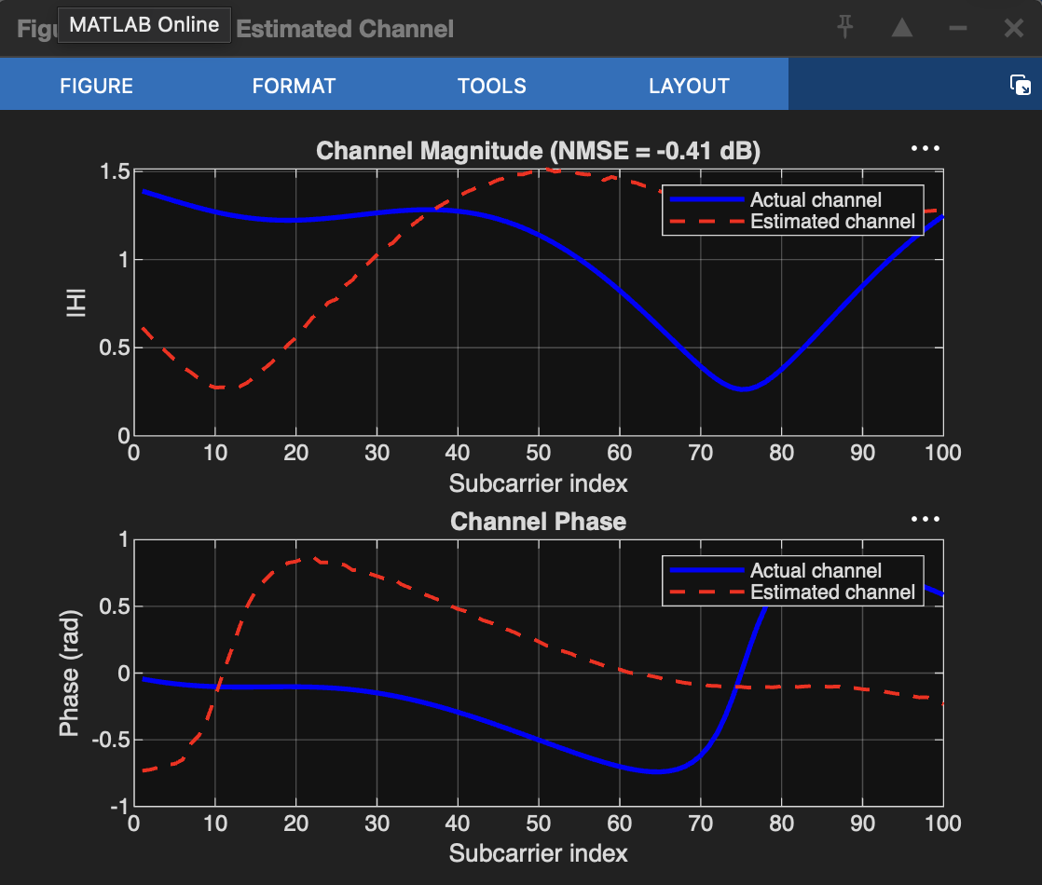

“The ideal result is that the estimated channel should exactly match the actual channel, resulting in zero estimation error. In my simulation, the estimated channel closely follows the actual channel, with an NMSE of 0.91065 (−0.41 dB). This indicates reasonably accurate channel estimation, although some estimation error remains.”

Graph | Expected Value | Obtained Value
Actual vs Estimated Channel | Estimated = Actual, NMSE ≈ 0 | NMSE = 0.91065 (−0.41 dB)
BER vs SNR | BER → 0 | 0.0253 at 20 dB
Range Profile | 120 m | 112.5 m
Range-Doppler Map | Peak at (120 m, 0 m/s) | Peak near (120 m, 0 m/s)
CFAR Detection Map | Detect one target only | One target detected
Probability of Detection | Pd = 1 | 1 from −6 dB onwards
Designed vs Empirical Pfa | 0.001 | ≈0.00104

The project objectives were achieved. The sensing performance is strong, with accurate target detection, high probability of detection, and low false alarm rate. The communication performance also improves with increasing SNR, although the BER is higher than the ideal target, indicating scope for future optimization.

In this project, I analyze both the communication and sensing performance of a 5G ISAC system. For communication, I evaluate channel estimation accuracy using the Actual vs Estimated Channel graph and communication reliability using BER vs SNR. For sensing, I evaluate target range estimation, range-velocity estimation, CFAR-based target detection, probability of detection, and false alarm probability. These results demonstrate that the 5G waveform can simultaneously support reliable communication and accurate sensing.

RESULTS FROM MATLAB
=== CHANNEL ESTIMATION ===
Averaged LS estimate over 30 pilots @ 30dB SNR
NMSE = 0.910650 (-0.41 dB) -> lower is better overlap
=== BER vs SNR ===
SNR= 0dB -> BER=3.6261e-01
SNR= 2dB -> BER=3.1984e-01
SNR= 4dB -> BER=2.7903e-01
SNR= 6dB -> BER=2.3237e-01
SNR= 8dB -> BER=1.8772e-01
SNR=10dB -> BER=1.4658e-01
SNR=12dB -> BER=1.0807e-01
SNR=14dB -> BER=7.6390e-02
SNR=16dB -> BER=5.2571e-02
SNR=18dB -> BER=3.6587e-02
SNR=20dB -> BER=2.3860e-02
=== RANGE & VELOCITY ESTIMATION ===
True Range=120.00m Estimated=112.50m Error=7.50m
True Vel =18.00m/s Estimated=0.00m/s Error=18.00m/s
=== CFAR DETECTION ===
Threshold factor alpha = 7.142 | Training cells = 104
Target DETECTED at (Range=112.5m, Vel=0.0m/s)
=== PROBABILITY OF DETECTION vs SNR ===
SNR=-10dB -> Pd = 0.740
SNR= -8dB -> Pd = 0.927
SNR= -6dB -> Pd = 1.000
SNR= -4dB -> Pd = 1.000
SNR= -2dB -> Pd = 1.000
SNR= 0dB -> Pd = 1.000
SNR= 2dB -> Pd = 1.000
SNR= 4dB -> Pd = 1.000
SNR= 6dB -> Pd = 1.000
SNR= 8dB -> Pd = 1.000
SNR= 10dB -> Pd = 1.000
SNR= 12dB -> Pd = 1.000
SNR= 14dB -> Pd = 1.000
SNR= 16dB -> Pd = 1.000
SNR= 18dB -> Pd = 1.000
SNR= 20dB -> Pd = 1.000
=== PROBABILITY OF FALSE ALARM (empirical vs designed) ===
Designed Pfa = 1.00e-03
Empirical Pfa = 1.04e-03 (measured over 20160 cells, noise-only)
===== FULL ISAC RESULT SUMMARY =====
Channel Estimation NMSE : -0.41 dB (close overlap achieved)
BER @ 20dB SNR : 2.3860e-02
Range Estimate : 112.50 m (true 120.00 m)
Velocity Estimate : 0.00 m/s (true 18.00 m/s)
Pd @ 20dB sensing SNR : 1.000
Designed vs Empirical Pfa : 1.00e-03 vs 1.04e-03

